When they select these programmes, they have to answer to the following obligatory questions:

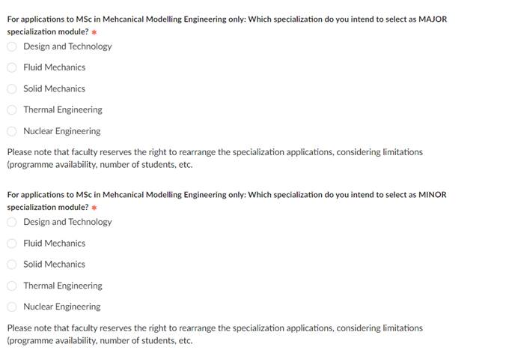

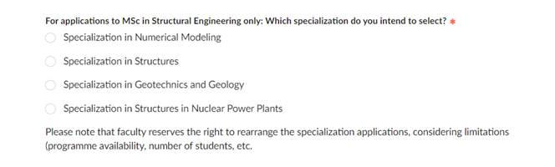

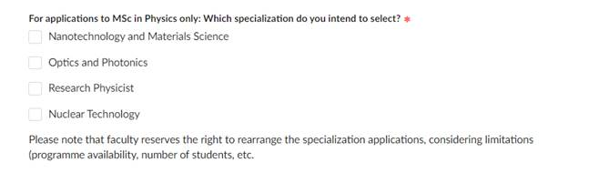

These data can be downloaded from the Tables by selecting the following questions:

