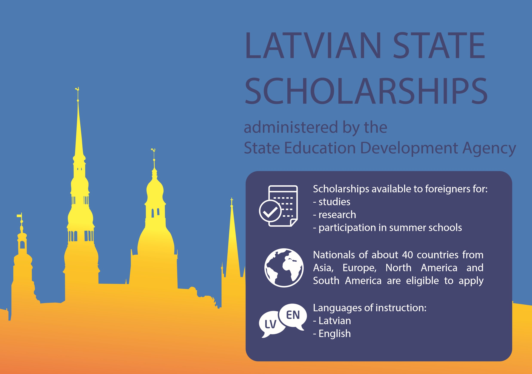



**Scholarship for**

**studies**

(10 -

11 months

)

students of bachelor,

master and doctoral

programmes

1

st February

st April

1



**Eligible**

**applicants**

**Call for**

**applications**

**opens on**

**Deadline for**

**application**

**www.viaa.gov.lv/scholarships scholarships@viaa.gov.lv**



**Fellowship for**

**research**

(

up to 5 months

)

academic and

research staff of higher

education or research

institutions

st February

1

1

st April



**Scholarships for**

**participation in**

**summer schools**

students and academic

staff of foreign higher

education institutions

1

st February

1

st April